[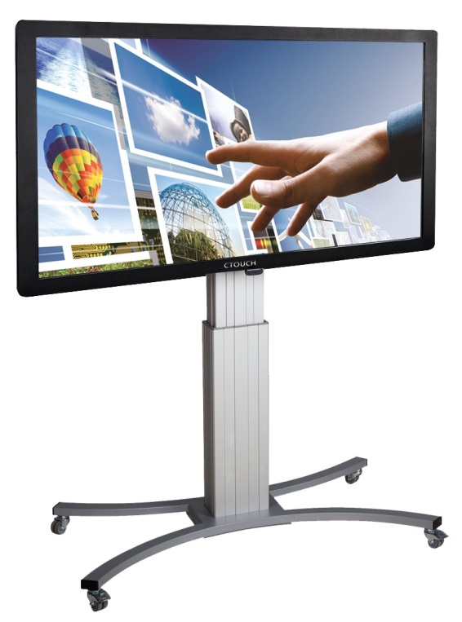](http://www.google.co.uk/url?sa=i&rct=j&q=&esrc=s&source=images&cd=&cad=rja&uact=8&ved=0ahUKEwjvs_-Oz-XMAhVKOMAKHaJ4CcEQjRwIBw&url=http://www.touchscreen-digiborden.nl/veelgestelde-vragen&psig=AFQjCNEJIpKoZzmRwUhk9I4ElXk7L2dUfA&ust=1463729398635988)[](http://www.google.co.uk/url?sa=i&rct=j&q=&esrc=s&source=images&cd=&cad=rja&uact=8&ved=0ahUKEwj_gcfs0OXMAhXLLsAKHaYBDQoQjRwIBw&url=http://www.mk2.nl/site/26-185-Gecertificeerd-CTOUCH-dealer.php?page%3D3&psig=AFQjCNHglX2oR25vuVBXByYKvaCTYLnbvw&ust=1463729694921168)

**Our students to experience** the power of touch!