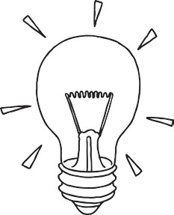

What do I want to learn?

Complete each of the phases below. You cannot move on to the next phase unless you have completed the steps before.

Phase 1: My Goal – Identify something that you want to learn or improve on.

Personal Goal Setting

What do I know about it already?

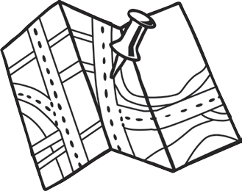

Phase 2: My Plan – Identify how you will achieve the goal you

set in Phase 1.

What can I do to achieve my goal?

What could stop me from achieving my goal?

What can I do to overcome this?

When will I do this?

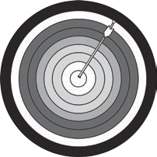

Phase 3: Evaluation – Reflect on your progress against the goal.

What actions have I taken?

Have I achieved my goal?

What could I do differently next time?