The Meadows School

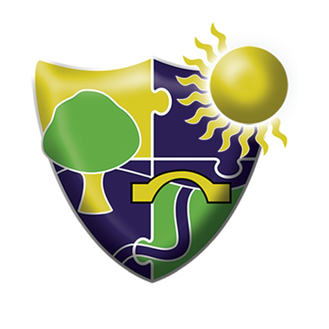

Communication Strategy

If any support or advice is needed regarding Communication, please do not hesitate to email: ariane.parcell@themeadows.sandwell.sch.uk
The Importance of Communication
At The Meadows School we use a Total Communication approach. Communication is an essential part of everyday life. It is also a fundamental human right. It is our primary means of accessing and conveying information and expressing our needs and wants. It is how we explain our thoughts and emotions and interpret those of others, make choices, express feelings and build relationships. It forms the basis of how we interact socially with others.
It is not uncommon for students with additional needs to have communication difficulties. These difficulties may include students who communicate verbally most of the time or some of the time and those whose communication is mostly non-verbal. These students often struggle to communicate their needs, wants and/or opinions and as a result use behaviour as their voice. By supporting students to use alternative and augmentative (AAC) ways to communicate, we can increase their positive interactions and provide them with opportunities to understand and express themselves fully. We call this a total communication approach.
Communication resources are available to all students at school. All students have an identified mode of communication as recorded on the student matrix and on communication passports situated in classrooms, alongside the communication audit.
Many of our students at The Meadows School find communicating very difficult and may have difficulties understanding what people say to them. We have a multi-agency approach at school. The school are privileged enough to work alongside Speech and Language Therapists. Speech and Language Therapists (SaLTs) support staff and students to help staff know what sort of communication tools and systems will be the best for the students we work with, and to help develop their communication skills.

We do this by assessing individual pupil’s speech, language and communication skills, and we aim to do this within a term of them starting at the school. We may also re – assess a student’s skills at the request of staff or parents.

SALTs assess in lots of different ways which may include:

- Observing from a distance.
- Observing and joining in a lesson.
- Talking to teaching and support staff, and parents to find out about how the pupil understands and communicates.
- Working with a student1:1 or in a small group.
- Using formal assessments and information from other professionals.
- Informal assessment (play or informal activities to help us find out specific information).

When we assess a student’s communication skills we are looking to find out:

- Expressive and receptive language: Do they use sounds, words, gestures, signs, photos etc to express their wants, needs, requests, protests, refusal etc. How, what and how much they understand of what we say?
Expressive communication refers to the ability to communicate and the methods and strategies a pupil uses to communicate.
Receptive communication refers to the ability to receive and understand a message.
- What helps them to understand and / or express themselves more clearly?

With this information we can then work with staff, students and parents to identify what needs to be available in the students learning environment to support their receptive and expressive communication. We can also identify if they need a form of Alternative Augmentative Communication, and work together to help them develop any specific skills they need, to use their communication system. SALTs use this information to support teachers set communication targets for the pupils, specific for the students personal learning grid (PLG) and to help them to understand how pupils’ speech and language is developing and what can be done to promote this.

The Total Communication Umbrella at The Meadows

We all need to think carefully about how to create a classroom environment which promotes communication. Pupils at The Meadows need to be given cues on a daily basis to allow them to access the curriculum. When teachers are planning, they need to consider how they can improve the Communication Environment in their classroom. Some of the cues which are in use at The Meadows are listed below.

-Visual Timetables (Appropriate to the needs of the students)

The use of Visual Timetables prepares the pupils for their day and more importantly for any changes that may occur in the timetable. Visual timetables are used widely in school. When pupils are able to anticipate what is happening next, they can be more actively involved and access the curriculum more effectively.
Teachers will need to make sure they have printed and laminated all the symbols or pictures for the lessons that their pupils may encounter during the week. These can be found in the communication folder on the Pupils need some time and space to put their timetable together in the morning, either independently or with a member of the class team.

A copy of symbol for the visual timetable can be found in:

T:\Planning\6b. Communication

Please add any symbols that may be missing however ensure they are colour coded with the correct bubble area.

- Class Communication Sheets

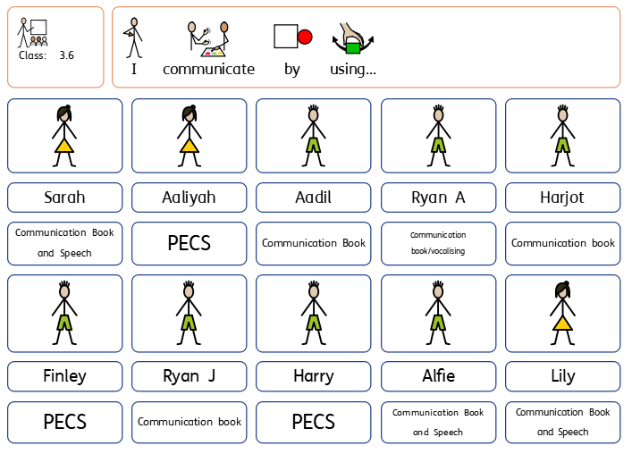
Placed on every classroom door these signs show the current communication methods for each pupil in that class highlighting communication is a priority. The levels are reviewed termly by the Class team or as and when communication may change.
The information displayed on these signs ensures that all adults working in the team or any visitors know exactly how to effectively communicate with pupils. It enables us to ensure that pupils have the correct tools available to access the curriculum and to allow us to model the next steps in their communicative development.

A copy of these can be found in the following area:

T:\00 Communication\Classroom Communication Sheets

-Communication Passports/ Sensory Profile/PECS Passport
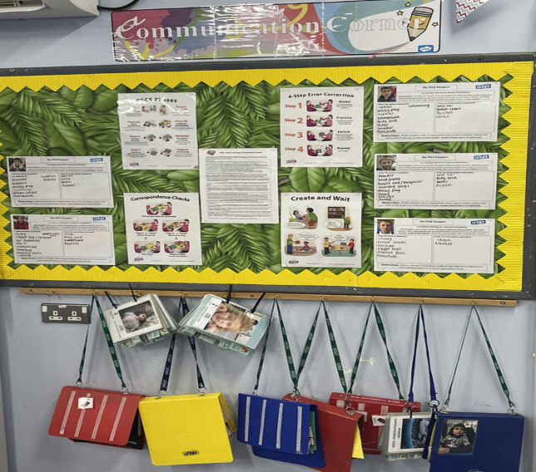
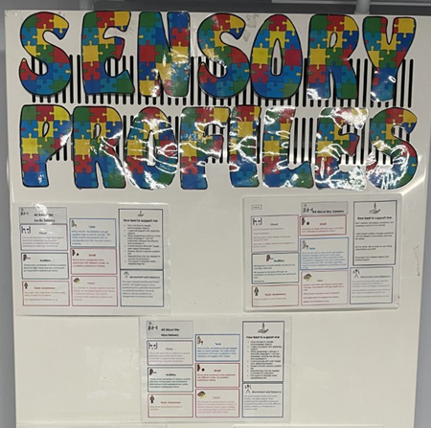

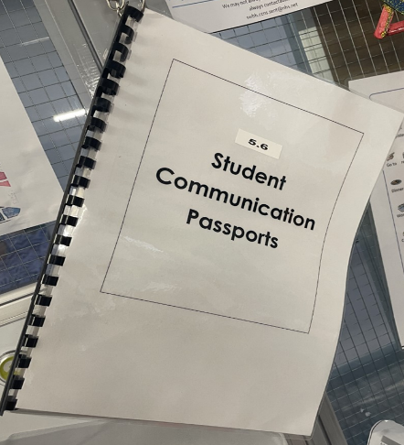

Ensuring all our kids leave with a functional, effective mode of communication, is our number one priority. Communication Passports will strengthen our provision in this crucial area, but they need to look different depending on the student’s Pathway.

- Climbers and Navigators: These are bound together and displayed on a hook in the classroom.
- Explorers: Sensory Profile are displayed on a wall in the classroom.
- Seekers: If they are PECS users, they need the PECS Passport for their phase (1, 2, 3A, 3B, 4). Please laminate the corresponding passport for each student. They need to be dynamic documents that list a student preferred / non-preferred item. These items will change over time; therefore, the passport must be easily amendable If students are working at PECS phases 5 and 6, they need the same Communication passport as their peers in Semi and Formal.
Please see your SaLTs, if you need any support.

All Passports and Sensory Profiles are found here:
T:\00 Communication\Communication Passports\Communication Passports

-Communication Audits

These are completed within the second half term (Autumn 2), allowing students to settle within the new school year and enabling reflective practice for staff. Student communication is identified and an overview given reflective of staff and students.
These documents are then shared with SaLTs and support given where needed.

These documents can be located: T:\00 Communication\Communication Audit

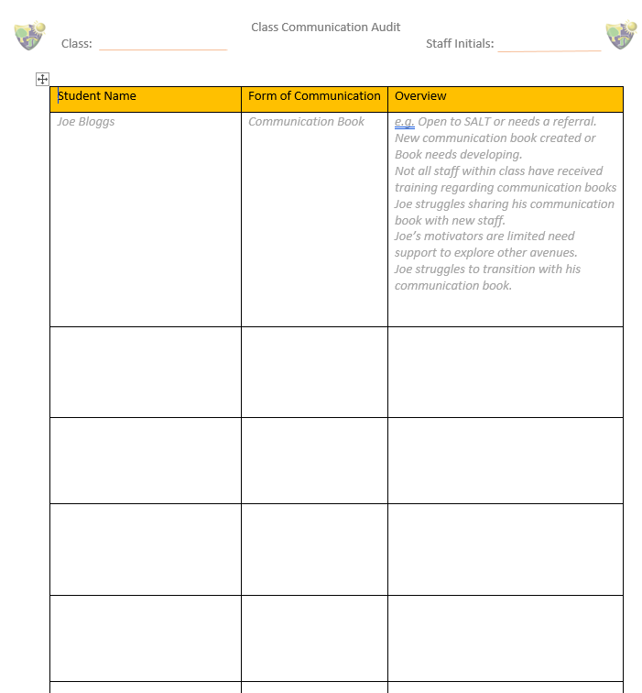

Intensive Interaction

‘Intensive Interaction is a practical approach to interacting with people with severe or profound and multiple learning difficulties and/or autism. The approach helps the person with learning difficulties and their communication partner to relate better to each other and enjoy each other’s company more. It helps them develop their communication abilities. In Intensive Interaction the carer, support worker, speech and language therapist or teacher works at being a better communication partner and so supports the person with learning disabilities develop confidence and competence as a communicator’.

The approach was developed by teachers Dave Hewett and Melanie Nind in the 1980’s. The approach can be used as a way of teaching fundamental communication, as a means of relationship building, or simply as a way of pleasurably spending time with people.
(Extracts from the British Institute of Learning Disabilities ‘Intensive Interaction Factsheet’)

Dr Dave Hewett identifies it teaches and develops the ‘Fundamentals of Communication,’ attainments such as: use and understanding of eye contacts, facial expression, vocalisations leading to speech, taking turns in exchanges of interaction and conversation.

Who is intensive interaction for?

It is intended that Intensive Interaction will address the needs of:
- People who are pre-verbal, with few or limited communication behaviours.
- People who are extremely socially withdrawn, and do not positively interact with other people.
- People who display various stereotyped or self-stimulatory behaviours that exclude the participation of other people.

Do you have to be an expert or can anyone do it?

There is nothing difficult or expert about Intensive Interaction. It is a very practical approach to communication and socialising that employs natural and easily recognisable techniques. It is theoretically simple and was developed from a model of ‘infant/caregiver interactions’, and therefore it involves the kind of activities through which sociability and communication normally develop in infancy.

It is a fun process and can be used as a way of teaching fundamental communication, as a means of relationship building, or simply as a way of pleasurably spending time with people. The nature and intensity of the activities might vary between noisy rough and tumble activities, intense mutual face-to-face studying or simply quietly sitting together in close physical proximity.

By using the various activities as a catalyst for social interaction we hope to facilitate a progression from passivity or social non-engagement, through turn-taking and contingent action, to the eventual initiation and leading of interactive games.

How do you go about it? What do you actually do?

When we adopt Intensive Interaction as an approach we go about things in a particular way – we adopt a particular interactive style. We try to develop a calm, accepting atmosphere, recognising that the motivation for each participant to socially interact with us has to be right – any interactive activity has to be within their realm of interest.

We adjust our interpersonal behaviours, trying to make ourselves more interesting by perhaps altering our voice or body language. We may also follow our client’s lead – responding to the things they do, involving ourselves in their activity in a way that does not make any demands on them that they cannot cope with. We use timing and rhythm in the interactions, making them mutually enjoyable – adding anticipation and drama to hold the person’s attention. We try to create the feeling of taking turns. We communicate that we value them and enjoy being with them.

We use sensitive observation to judge how well an interaction is going. We respond quickly to any feedback, interpreting it so that we can keep the interaction positive and enjoyable for both partners. We collectively reflect on the interactions and think about how we can enhance and extend them.
If we do all these things with Intensity, Sensitivity and Perseverance then can we claim to be using Intensive Interaction.

What are the potential outcomes?
The body of evidence concerning the responses of people with severe or profound learning disabilities to Intensive Interaction is currently unambiguously supportive. There are repeated claims of novel or increased socially interactive behaviours. Such positive developments are reported as greater use of eye contact; increased toleration of, or engagement in, physical contact activities; additional episodes of sustained joint attention; increased use of potentially communicative vocalisations and an increased regard for facial signing.

Please see the guidance document saved in the following:

T:\00 Communication\Intensive Interaction

Objects of Reference (OOR)

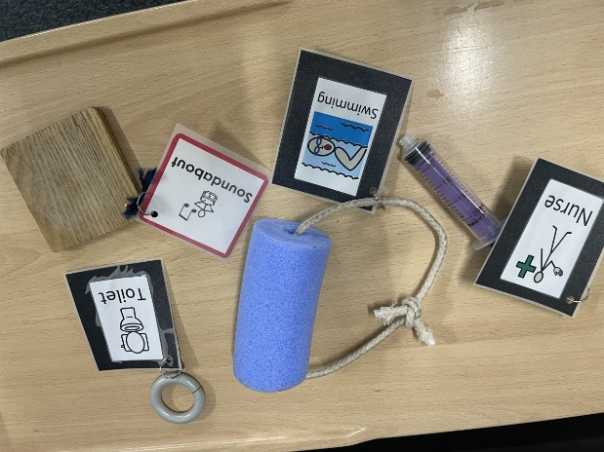
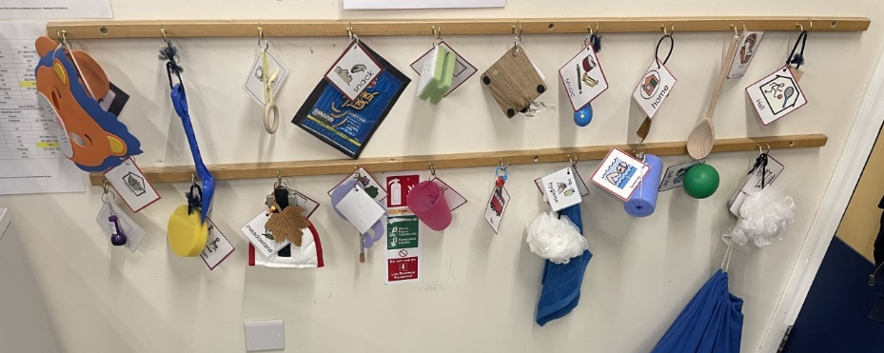
An object of reference is a whole physical object, or part of an object, that you hold or touch to represent or identify:
- Person
- Object (item)
- Location (Place)
- Event (Activity)

Who uses Objects of Reference?
You can use objects of reference to communicate, if you have complex disabilities and find it hard to use speech, written words, signing, or photographs and symbols.
Objects of reference are helpful if you have one or more of the following:
- Sight loss.
- Hearing loss.
- Multi-sensory impairment.
- Autism spectrum disorder.
- Learning disabilities.
- Short- or long-term memory difficulties.
Objects of reference are also helpful for parents, family members, friends, therapists and school and support staff communicating with people with complex disabilities.
Why do we use OOR?
At The Meadows objects of reference help individuals to communicate. They help students:
- Increase understanding of spoken words
- Signal the beginning of a new activity
- Enable the person to make their own choices and request items and activities
- Provide a visual representation of their day
- Supports memory and concentration skills
- Ability to control their environment
- Increase independence
How to use OOR?
- Context is crucial in the early stages
- Initially introduce one OOR within everyday situations
- Need to ensure successive presentation of the OOR, e.g., a cup followed immediately by a drink
- May need to repeat the sequence of actions many times before the link is made
- Important to use a consistent approach
- Can be used alongside other communication systems e.g., TaSSeLs
- Don’t move on until the first OOR has been successfully introduced.
Three stages when learning to use OOR:
- Anticipation – start to learn what is going to happen next, by seeing OOR for that activity
- Choice Making – once student knows that an OOR means that something specific is going to happen. Give them a choice of two OOR and ask what they want to do next
- Initiation – once student knows that they can choose what they want to happen, they will feel that they have some control over their world. Can then use their OOR to ask for things for themselves without any help from others.

TaSSeLs (On-body Signing)

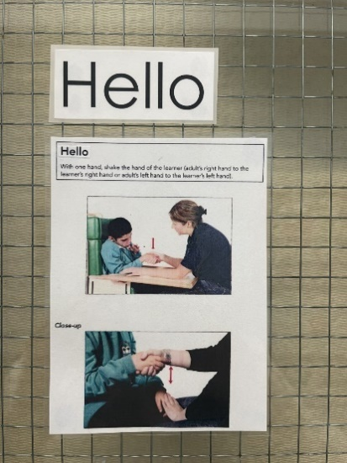
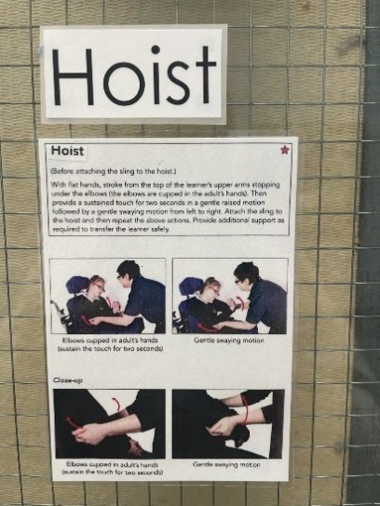
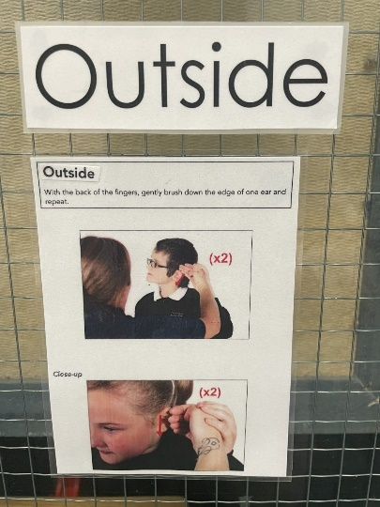

TaSSeLs is an acronym for Tactile Signing for Sensory Learners. At The Meadows school, majority of students within the Pre-formal Pathway access TaSSeLs. TaSSeLs is a system of touch cues to aid understanding de4signed to support the early stages of communication. TaSSeLs alerts the student that something is about happen.
Who uses TaSSeLs?
Students who:
- Are making limited or no progress with other communication systems
- Have complex learning difficulties, some of whom may also have a visual impairment
- Require additional sensory feedback to aid their learning
Why use touch?
- Touch is a vital channel of communication for learners at the earliest developmental levels
- It is the first sense we acquire as infants; we begin receiving tactile signals even before birth
- Learners with the most profound needs are “constantly being touched, turned, handled, and placed in a variety of positions” (Longhorn, 1988)
- “Touch offers individuals with significant multiple disabilities access to communication” (Goold and Hummell, 1993)

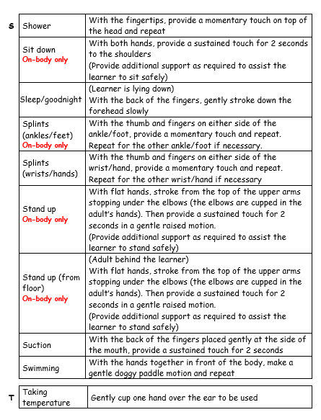
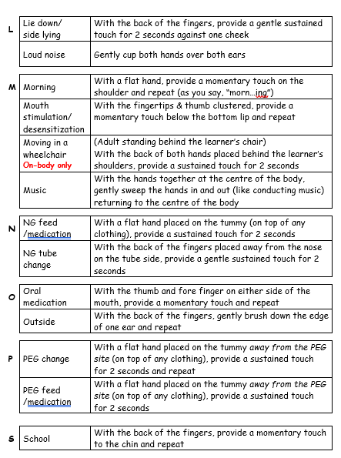
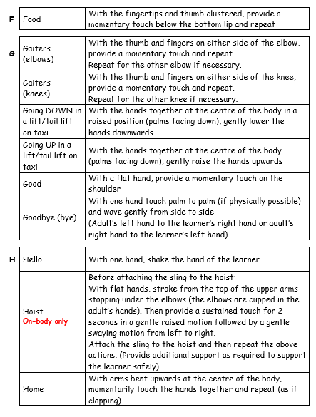
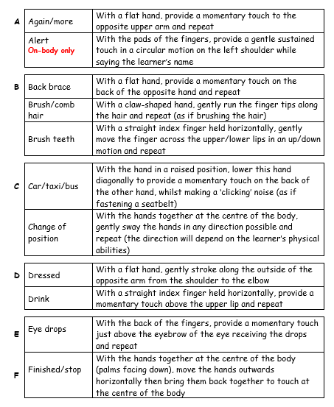
A-Z descriptors

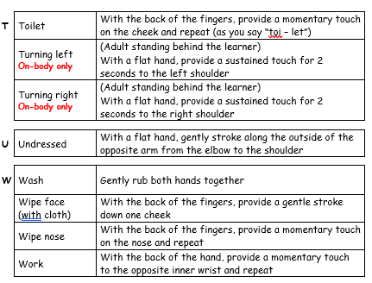

TaSSeLs Profile
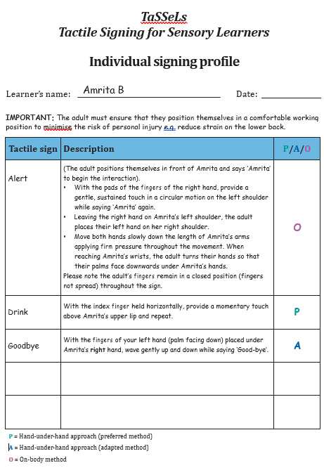
The TaSSeLs profile can be found in the following location:
T:\00 Communication\TaSSeLs

PECS (Picture Exchange Communication)

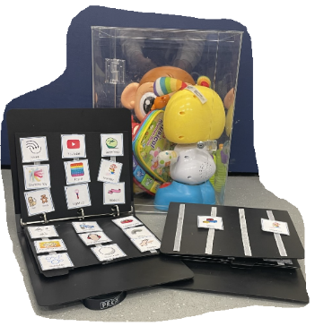
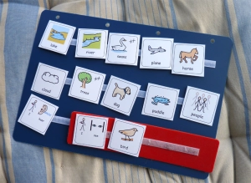
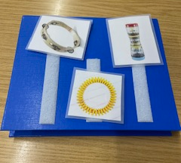

PECS consists of six phases and begins by teaching an individual to give a single picture of a desired item or action to a “communicative partner” who immediately honours the exchange as a request. The system goes on to teach discrimination of pictures and how to put them together in sentences. In the more advanced phases, individuals are taught to use modifiers, answer questions and comment.
PECS begins with teaching students to exchange a picture of a desired item with a teacher, who immediately honours the request. For example, if they want a drink, they will give a picture of 'drink' to an adult who directly hands them a drink. Verbal prompts are not used, thus encouraging spontaneity and avoiding prompt dependency.
The system goes on to teach discrimination of symbols and how to construct simple "sentences." Ideas for teaching commenting and other language structures such as asking and answering questions are also incorporated. It has been reported that both pre-school and older students have begun to develop speech when using PECS. The system has been successful with adolescents and adults who have a wide array of communicative, cognitive and physical difficulties.
Students at The Meadows who use PECS will have both a communication passport and a PECS passport.
PECS Asda orders occur every two weeks and each class has a £5 budget, the order form can found in the following area.
Found in the following area: T:\00 Communication\PECS

PECS Phases

Phase I: How to Communicate- Students learn how to exchange single pictures for items or activities that they really want. It is important that the communication partner finds out what the child has interest in so that he or she isn’t prompted into asking for something they don’t like. We should never make PECS aversive.
Phase II: Distance and Persistence- Still using single pictures, students learn to generalize this new skill by using it in different places, with different people and across distances. This phase is also utilized for the purpose of expanding spontaneity from the child.
Phase III: Picture Discrimination- Students learn to select from two or more pictures to ask for their favourite things. These favourite things are placed in a communication book- a three ring binders with Velcro strips where pictures are stored and easily removed for communication.
Phase IV: Sentence Structure- Students seek out their PECS board, and learn to construct simple sentences on a detachable sentence strip using an “I want” picture followed by a picture of the item being requested. Students then seek out a communicative partner, and give him or her the sentence strip. Listeners read the strip back to the child, inserting a fixed time delay between the words “I want” and the item label. Additional social praise is added if a child independently provides the label during the delay.
*Attributes and Language Expansion* At this point, students begin to learn to expand their sentences by adding adjectives, verbs, and prepositions.
Phase V: Answering a direct question- Students learn to use PECS to answer the question, “What do you want?”
Phase VI: Commenting- Now students are taught to comment in response to questions such as, “What do you see?”, “What do you hear?” and “What is it?” They learn to make up sentences starting with “I see,” “I hear,” “I feel,” “It is a,”etc.

Blank Level Questioning
What are the Blank Levels of Questioning?
The Blank Levels of Questioning, sometimes known as the Language of Learning model, was developed by Blank, Rose and Berlin in 1978. Its main aim is to develop children’s verbal reasoning and abstract language capabilities. The model was established when its creators studied the language used by teachers in classrooms. They found that questions could be categorised into four different levels which are explained below. These start with basic questions, that ask for simple and concrete responses, and lead up to more complex questions that require abstract answers. It is important that questions are pitched to children at the correct level, in order to support their understanding of the task in hand. More difficult questions can be simplified and brought down a level, or cueing techniques and strategies can be used to help the child respond.
Level One – Matching Perception
“Right there – the answer is in front of you”
Children are required to match their immediate perception to language, and so respond to simple commands which involve matching what they are seeing to what they are hearing. The child focuses on the whole object.
Level Two – Selective Analysis of Perception
“Think and search – the answer is in front of you but you need to look for it”
Children are still required to match language on to their immediate perceptions, but they must focus more selectively on material. They are introduced to concepts, both concrete and abstract, which enable them to describe objects and determine how things are different, eg a ball can be round, hard or soft, red or blue, plain or spotty, big or small. This descriptive language helps children to understand simple stories or describe pictures. They focus on part of the object.
Level Three – Reordering Perception
“The author and you – the answer is not in front of you, use clues from the
book and form your own answer”
At this level, children can use language to restructure and reorder their perceptions and experiences. They are expected to have an understanding of language itself and will be required to use language to talk about language. They are expected to make deductions or generalisations about a situation and to be able to make a common link in order to group information together. Children have to focus on the object in its context.
Level Four – Reasoning About Perception
“In your head – the answer is not in front of you – it is your own opinion”
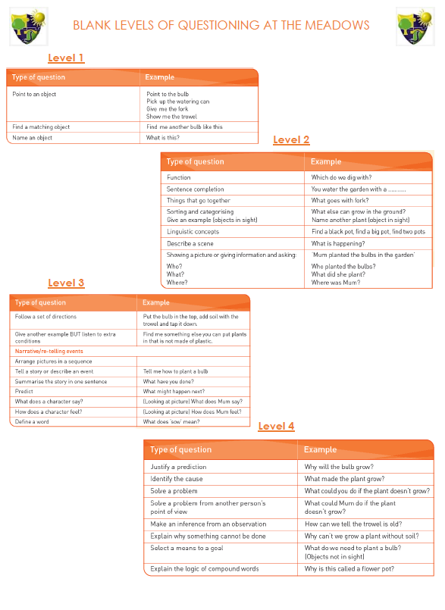
This level requires children to solve complex and abstract verbal problems. All ‘why’ questions are level 4. Children have to think about the relationships between objects, people and events and give reasons why things happen. They have to justify why events have occurred and why they are making a particular prediction.

Aided Language Displays (ALDs)
An aided language display (ALD) is a symbol display where all the relevant vocabulary has symbols for specific activities (e.g. a game such a Kim’s game or Snakes and Ladders; a meal time or wash time task; or a classroom topic) are all displayed on a single page. This ensures that symbols are accessed in activities without flicking through pages in a communication book. Colour is important.
Aided language displays are usually created in the following way:
1. Classroom activities suitable for ALD are identified and prioritised
2. Messages and vocabulary sets associated with the activities are generated/ brainstormed
3. Decide how symbols will be selected and how many, then format display
4. Communication displays are created
5. Supplemental aided and augmentative symbols are added as appropriate
6. Displays and supplemental systems are made accessible for the student
Classroom activities selected should include popular and frequently used activities in the classroom. These could include cooking, music time, games, working on the computer, and reading a book (rather than just the popular snack time activity most people use).
Vocabulary is usually selected from recording or brainstorming words most used in an activity - and this does not just mean the names for objects. This can include social words (e.g. yuck, oh oh, your turn, you look funny), action words (turn the page, throw the dice, fall down, clap hands), people, and modifiers (more, big, gone, again).
Symbols can be introduced one at a time or twelve to one page, and so on. Vocabulary can range from one or two symbols upwards to 12 or 36 or even more. This will depend on the time the child has been exposed to symbols, what symbols the child knows and understands, as well as the child’s learning and visual skills. Symbols can be displayed in a book, on a board, or attached by Velcro on a board.
For a young child a blowing bubbles activity might begin with the symbols of ‘pop’, ‘more’, ‘go’, and ‘blow’. For an older child cooking or looking at books the vocabulary could be much more.
Suggested activities where ‘Aided Language Displays’ may be appropriate include:
- Game activities e.g., snakes and ladders, what’s gone, Kim’s game (student to point to symbol to say what is gone or hidden)
- Reading a book (to comment on who is in the book, what is happening, verbs, concepts)
- Getting dressed
- Classroom activities e.g., Cooking, greetings
- Topic work
- News Time
- Circle time
- Cooking
- Music Time
- What am I doing today?
- Asking for items to complete an inset puzzle.
Getting started
1. Select just a few activities that you do regularly throughout the weeks e.g., washing hands, music time, circle time activity.
2. Decide on the vocabulary used in the activity - either brainstorm or get a colleague to record vocabulary you use. Then highlight the words most often used, if child can understand and select pictures from a choice of twelve, write down the 12 most common messages or words used. If less - then choose what might be appropriate.
Remember to include social words, action words, and modifiers - e.g.
Music Time: listen, look, shake, yeah, noisy, ring, bells, etc.
Washing hands: dirty, wash, tap, on, off, soap, clean, etc.
3. Make up symbols for a single page -
4. Carry out activity. When starting, it is important that the helper says the words and points to the symbols herself. Do not make the child point. Once they see you doing it, after a while they may wish to use a sheet and they can use yours or be given their own copy.
5. Once you have created a master sheet, such as things to do in cooking (hot, cold, I want, mix, umh, I like that, yuck, I don’t like that, mix, pour, etc.) you may wish to have additional sheets that you can add that include the materials required for each activity. For cooking you may wish to have an extra sheet one week for making a sandwich, and another week for making a cake.
6. Make sure ALD’s are stored where they can be easily found. You might keep them with the activity itself or, for classroom routines, in a basket where they can be easily retrieved.

AIMS OF AIDED LANGUAGE DISPLAYS
-This will hopefully lead the child to access symbols to allow greater communication and control when communicating with others.
-This is also a useful tool for some children in acting as a bridge to literacy skills as the symbol is always accompanied by written text.
-By using symbols in this way, the child may begin to communicate in a functional way, in various activities throughout the day.
Based on information in Glennen, S. and DeCoste, D (1998) Handbook of Augmentative and Alternative Communication Singular: San Diego

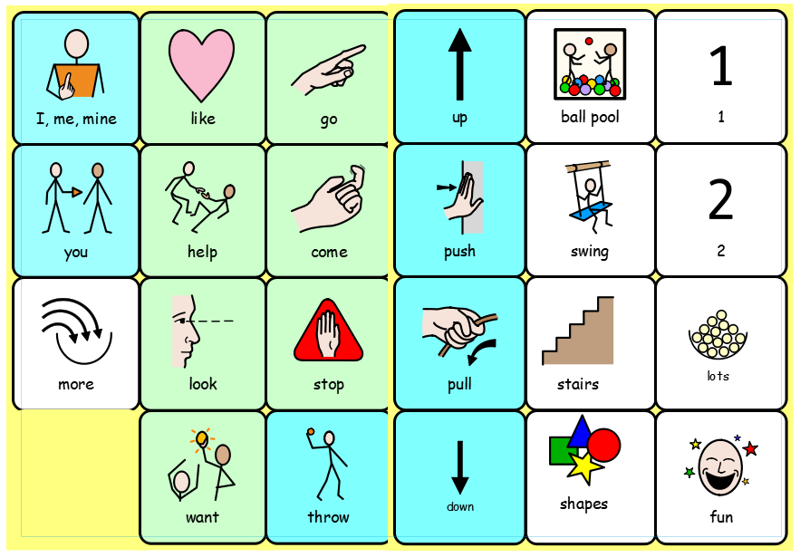

Support and guidance, along with examples can be found in the following area:
T:\00 Communication\Aided Language Displays

Communication Books
Many pupils have their own communication book made up of symbols and photos. The content can be personal to the pupil’s life and tailored to their lessons at school. It is important to keep the content up to date and relevant as the pupils get older and progress. Often pupils point to the symbols either using their finger or their eyes to access the book.
At The Meadows School we have our own standard communication book supported and provided by Speech and Language Therapists.
If a pupil has a communication book it is important to use it to enable that pupil to access the curriculum. When you are planning your lessons refer to the book to make sure it contains appropriate symbols or photos. If not then you will need to use Communicate in Print or new photos to update the book. Alternatively print a sheet just to use for a one-off lesson.
Communication books will be supported by (Speech and Language Therapists) SALT’s The master copy of all versions is saved here: T:\00 Communication\Communication Books\Master communication book 1-5

PODD Communication Book
Pragmatic Organisation Dynamic Display

PODD stands for:
- Pragmatic – the ways that we use language socially
- Organisation – words and symbols arranged in a systematic way
- Dynamic Display – changing pages.

Background

- PODD is a way of organising whole word and symbol vocabulary in a communication book or speech generating device to provide immersion and modelling for learning.

- The aim of a PODD is to provide vocabulary:

- for continuous communication all the time
- for a range of messages
- across a range of topics
- in multiple environments.

- PODDs can have different formats, depending on the individual physical, sensory and communication needs of the person who will use it.

- PODDs have been developed over the past 15 years by Gayle Porter, a speech pathologist with the Cerebral Palsy Education Centre (CPEC) in Victoria. Each PODD format has been shaped by the experiences of both children with complex communication needs (CCN), and their communication partners.

The Speech and Language Therapists will support and advise if a student requires a PODD communication book.
For additional information: T:\00 Communication\PODD Communication

Makaton
Like all other forms of AAC, signs are used at The Meadows school to support pupils to understand spoken language and to express themselves. Signs are the most portable form of AAC and you do not need any other equipment to use signs. Here at The Meadows School, we use mainly Makaton Signs alongside our spoken words to emphasise the words with the most meaning. The benefit of signs is that although words are fleeting, signs can last a little longer, and give a visual clue to the words.
Weekly during Monday briefing we have ‘sign of the week’ which is shared by part of the communication bubble team.

Communicate In Print 3
Communicate In Print 3 is a desktop publisher for creating symbol materials to print, such as symbol books, flashcards, worksheets and accessible documents.
Communicate In Print 3 uses Widget’s smart symbolising technology and is supplied with more than 15,000 Widget Symbols, which have been developed to support communication, access to information and many schools’ curriculum subjects. It is a teaching and learning tool and is used to create many communication aids such as Aided Language Displays and communication books.
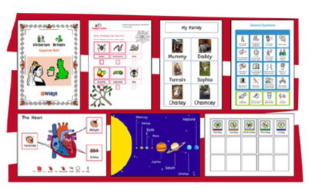

Etran Frame
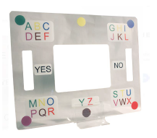

Some pupils use an Etran frame to enable them to access symbols, photos or words. These pupils may have limited control of their upper body but have good control of their head and/or eyes so they can eye point (gaze towards their chosen symbol).
The symbols or photos can be Blu Tacked onto frames or slotted into the frame like the Etran above. It is important to consider the extent to which each pupil can see them. The Etran above is a complex frame whereby pupils can choose up to 16 symbols using a system which can be colour coordinated.
For some pupils as above, it would be more appropriate to have four or eight large symbols to choose from. If a pupil has an Etran frame it is important to use it to enable that pupil to access the curriculum. When you are planning your lessons, you need to consider what symbols or photos you might need for the Etran frame. You can print symbols from Communicate in Print to use with an Etran frame.
Switches
Many pupils at The Meadows use switches to allow them to be able to access the computer. Some may also use voice output switches to enable them to communicate using simple switch devices such as a Big Mac. There is a wide range of software available.
There are different stages of development in the use of switches:
- Cause and effect—understanding that something will happen when the switch is pressed
- Build– pressing the switch several times to elicit reward
- Turn taking
- Timing—requires perceptual and cognitive skills to control single switch scan
- Scanning—this would include 2 switches, timing, looking and listening
We have many different switches available for pupils to try. Some of our pupils require the switches to be mounted onto their wheelchairs to enable them to be able to use them easily. An example of this would be a head switch for a pupil who is unable to use their hands. There is a wide range of software available which can be switch activated.

VOCAs
Some Pupils use a VOCA to enable them to access the curriculum. These pupils have a good understanding of symbols but have difficulties with speech. Symbols are programmed into the device and when the pupils press the symbols the device ‘speaks’ for them. There are a range of VOCAs in use at The Meadows and they all have differing systems of programming. Teachers and Teaching Assistants should liaise with the Communication Team about how to update each VOCA. If a pupil has a VOCA it is important to use it to enable that pupil to access the curriculum. When you are planning your lessons refer to the VOCA to make sure it contains appropriate symbols.
If it, doesn’t you will need to update the VOCA so that the individual can access the lesson.
Big Macs, Step by Step.
These are simple to use voice output communication aids. You can record a single message on a Big Mack or a series of messages on a Step by Step. They are very motivational devices and are useful if the focus is on turn-taking activities. Countless turn-taking activities can be created and incorporated into every aspect of the school day.
Alternative Augmentative Communication at The Meadows
Voice Output Communication Aids
Do’s
- Do look at me, not my talker.
- Do give me a very long time to respond.
- Do ask how I indicate “yes” and “no” if I don’t have my talker.
- Do read my facial expression and body language.
- Do ask me to expand/explain, rather than always asking me questions to which I can only say yes or no.
- Do check that I mean to say what I have said.
- Do make sure I can access my talker.
- Do talk to me at eye level.
- Do tell me things, it’s boring just to be asked questions.
- Do tell me when you want to move my chair– I’m not a sack of potatoes.
- Do take my VOCA to all lessons
Don’ts
- Don’t ask a question and then answer it yourself, or immediately turn to someone else for the answer.
- Don’t talk about me in front of me without acknowledging that you are
- being rude– and apologising.
- Don’t lean on my device or my wheelchair without my permission.
- Don’t anticipate what I’m going to say without asking “Can I guess at what you mean?”
- Don’t switch off my device because I’m being a pain or you disagree with me.
- Don’t laugh at my mistakes, it gets disheartening.
- Don’t just ask me questions.
- Don’t put me on the spot by asking me to demonstrate my talker unless I have agreed in private.
- Don’t stand behind me when I’m talking to you

Eye Gaze
Eye gaze is an exciting and innovative piece of assistive technology to become available to schools with students with physical disabilities.
With this tool we can observe what our students see, what they notice and don’t notice, what they prefer to look at and what sense they make of what they see. We must ensure that every time a student uses the eye gaze it is calibrated for the pupil.
It may appear that some of our students with complex needs are uninterested or not able to use technology, however using the eye gaze system can provide a fun and stimulating addition to the environment. It is important that we provide the correct resources and a wide range of games and activities to encourage students to want more and refine their skills with practice.
Any student that is motivated will learn.
Moving on from early interaction skills, the eye gaze device can have the capacity for some of our students to be able to communicate and even control their environment.

Glossary
- AAC - Augmentative and Alternative Communication
The different methods of communication people can use to either support speaking (augmentative) or use instead of speaking (alternative). At The Meadows AAC is used both as a means of expression by pupils, and as a way to support pupils in understanding and interpreting information.
- Access
The way in which an AAC user accesses their communication aid using whatever physical movements they can control, such as pointing with their hand or eyes (direct access) or scanning using a single switch or series of switches that can be activated with the hand, head or foot (indirect access).
- Aided Language display (ALD)
Is a symbol display where all the relevant symbolised vocabulary for a specific activity is displayed on a single page. This can be a core vocabulary as well as an activity linked vocabulary.
- Big Mac
A large circular switch that the user presses to activate a single recorded message. A ‘little mac’ is the smaller version of the switch.
- British Sign Language (BSL)
The language used by Deaf communities in the UK. BSL has its own word order and grammar and, like other languages, an ever-growing vocabulary.
- Communication Aid
A piece of equipment used to help an individual give or understand a message. These could be objects, symbols, a communication book, VOCA, etc.
- Communication Book
A book containing carefully selected photos, symbols or words, used by an individual to help them to communicate a message. The book can contain any number of symbols depending on the individual and often books will have different layouts depending on the individual’s method of access.
- Communicate in Print
A symbol-based computer software programme used to create individual symbols, symbols boards / language displays and communication books. It can also be used for literacy development.
- Communication Partner
The person who is ‘listening’ to the ‘speaker’. The ‘speaker’ may be using speech, signs, communication aids or body language and facial expression to communicate.
- Communication Passport
An individualised passport that includes information about the individual that they wish to share with others, such as the way in which they communicate, how to support them to eat and drink, what they like to do and their medical needs.
- Communication Environment
The way in which an environment is set up to support the communicator. A good communication environment will allow the user to easily access their method of communication and will support them in understanding what is being communicated to them.
- Communication Strategies
The strategies used by a communication partner to facilitate the individual, such as allowing time for the young person to respond.
- COSST

- Dynamic Device
A high-tech touch-screen communication aid. The page changes when a particular icon is touched.
- Etran Frame
A large Perspex frame that can be placed on a table top, with pockets to slot photos or symbols into. The young person uses their eyes to ‘point’ to a symbol or photo to convey a message.
- Eye gaze
The use of vision to control technology, access ICT, communication aids and the environment.
- Eye-pointing
Using the eyes to ‘point’ to or look hard in the direction of the intended object, person, place, photo, symbol or word.
- High-Tech Communication Aid
Any communication system that requires a battery to work. This may include switches and electronic devices that the young person uses to create messages. Pictures, symbols, words or letters on the device are pressed to activate an electronic voice (see VOCA also).
- Intensive Interaction
Intensive Interaction is a practical approach to interacting with people with severe or profound and multiple learning difficulties and/or autism. There is nothing difficult or expert about Intensive Interaction, it is a very practical approach to communication and socialising with people who do not find it easy communicating or being social’.
- Jelly Bean Switch
A very small switch that can be linked to another device.
- Low Tech Communication Aid
Any communication system that does not require a battery to work. This may include objects, communication books, symbols and photos.
- Makaton
A basic vocabulary of signs based on the signs of BSL. It is used alongside spoken English, following the same word order. It is intended to support speech rather than replace it.
- Object Cues
An object or set of objects used to let an individual know what is going to happen. The objects are used to represent a place, person or activity. Objects can also be used expressively by the individual as a way of telling the communication partner what they want.
- On-body Signs
A system of signing ‘on’ the young person’s body e.g., taking the young person's hand and drawing one hand over the other to signal ‘finished’. On-body signs are generally used to support young people with multi-sensory impairments and/or severe receptive language difficulties.
- PECS – Picture Exchange Communication System
A highly structured system of symbol exchange. The user gives a symbol to the communication partner in order to request an item or comment.
- Photographs
These can be used in a similar way to Objects of Reference to support the individual to know what is going to happen. The individual can also use photos expressively, for example, making a choice between 2 photos or having a communication book containing a set of photos.
- Powerlink
A device that allows a switch to be linked to a computer so that it can be used in ICT.
- Sequence Boxes
A row of boxes that can be used to cue pupils into a sequence of activities (e.g. the class timetable). Objects can be placed in the boxes to represent each activity.
- Signing
Using the hands to make different movements and shapes to communicate a message (see Makaton and BSL). Facial expression can also be an important part of signing.
- Step-by-Step
A switch that contains a sequence of recorded spoken messages. Each time the user presses the switch the next part of the message is activated.
- Switch
An electronic pad or button that the user presses to activate either a spoken message (e.g., a Big Mac) or an object / device (e.g., a switch-activated toy, computer or high-tech communication aid).
- Switch-activated Toy
An electronic toy (such as a jumping dog, bubble machine, fan) that is linked to a switch. When the user presses the switch, the toy is activated. Some kitchen equipment, such as blenders, can also be linked to switches.
- Symbols
Pictures that represent an object, place, concept, action or person. Symbols can vary in colour and size, and are generally printed from a computer programme (such as Communicate in Print or Board maker). Symbols can stand alone or be arranged on boards / language displays, in communication books or on a computer screen.
- Visual Timetable
A timetable that contains simple visual information using photographs or symbols to support pupils in preparing for their day.
- VOCA - Voice Output Communication Aid
Any electronic device that, when activated, produces a spoken voice to help individuals communicate a message. These devices can range from a simple device with a single message or series of recorded messages (e.g., big mac, step-by-step) or complex computer-based systems that allow the user to link together several words (from a choice of many stored words) to produce phrases and sentences.

Useful Websites
For information
www.communicationmatters.org.uk – a charity offering training events, free road shows, study days and information about AAC
www.thecommunicationtrust.org.uk – Contains information about working with and supporting children and young people with their speech, language and communication.
www.talkingpoint.org.uk – contains information about communication needs and how to support pupils with these difficulties
www.1voice.info – offers a network of support and information for pupils who use communication aids and their families
www.ace-centre.org.uk – provides information and advice on AAC
www.speechbubble.org.uk – contains searchable details of over 100 communication aids.
www.makaton.org – contains information about using Makaton signs and symbols
www.hello.org.uk – information about the campaign to increase understanding of the importance of communication skills. Lots of free resources.
For practical stuff
www.talksense.weebly.com – lots of ideas for using objects of reference and big macs in school
www.ican.org.uk – they have an enquiry service available for advice about speech and language development.
www.praacticalaac.org —lots of resources and tips and videos
https://hirstwood.com/ - sensory courses and ideas

